Index No. _________

MILITARY COLLEGE OF SIGNALS
Mid Term EXAMINATION – Number Theory
(BESE – 14)

Instructor: Dr Saeed Murtaza Date: November 06, 2010.
Max Time: 150 min Max Marks: 30

Note
- Attempt all questions in the given sequence.
- Understanding question is the part of examination.
- Show complete working, i.e., do not miss any point in your solution and do not leave any thing for the instructor to assume on your behalf.
- There are no marks for the procedure only.
- Attach question paper with the answer sheet.

Q. No. 1:
Determine whether each of the following sets is well ordered or not. Either give a proof using the well-ordering property of the set of positive integers, or give an example of a subset of the set that has no smallest element.
- the set of integers greater than 3
- the set of even positive integers
- the set of positive rational numbers
- the set of positive that can be written in the form “a/2”, where “a” is a positive integer.
[4]
Q. No. 2:
Show that 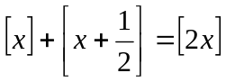 where “x” is real number.
[3]
Q. No. 3:
Use mathematical induction to prove that 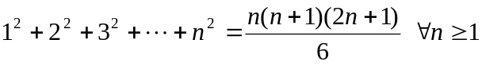
[4]
Q. No. 4:
Prove that 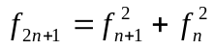 where 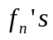 are Fibonacci numbers 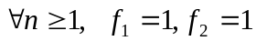
(Hint: Use Mathematical Induction)
[4]
P.T.O
Q. No. 5:
In 1999, to mail a first class letter in the USA it cost 33 cents for the first ounce and 22 cents for each additional ounce or fraction thereof. Find a formula involving the greatest integer function for the cost of mailing a letter in 1999. Could it possibly have cost $1.45 or $2.31 to mail a first-class letter in the USA in 1999?
[5]
Q. No. 6:
Show that if “a” and “n” are positive integers with “n > 1” and 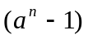is prime, then 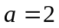and “n” is prime. (Hint:
[5]
Q. No. 7:
Show that if a, b, c and d are integers such that b and d are positive, (a,b) = (c,d) = 1 and 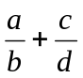is an integer, then 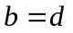
[5]

